OSSP – SKILL CONTENT DELIVERY CONCEPTS
25CS2104E
Simple C Programs – Copy/Paste Ready Linux Programs
QUESTION 1
To Install Linux VM, Configure GCC, Setup Git Repository, Create Project Structure, Understand Shell Architecture, Build Initial Makefile
#include <stdio.h>
int main() {
printf("Linux OSSP project is ready.\n");
printf("GCC and Makefile can be used to build this program.\n");
return 0;
}
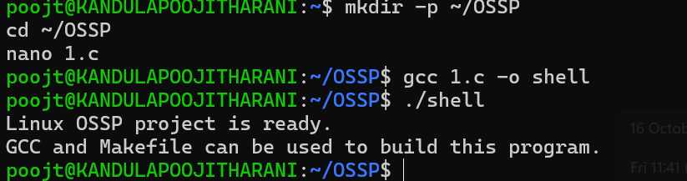

QUESTION 2
To Create Main Loop, Display Prompt, Read User Input, Handle Exit Conditions, Design Control Flow Diagram, Test Interactive Loop
#include <stdio.h>
#include <string.h>
int main() {
char input[100];
while (1) {
printf("myshell> ");
if (fgets(input, sizeof(input), stdin) == NULL)
break;
input[strcspn(input, "\n")] = '\0';
if (strcmp(input, "exit") == 0)
break;
printf("You entered: %s\n", input);
}
printf("Shell exited.\n");
return 0;
}
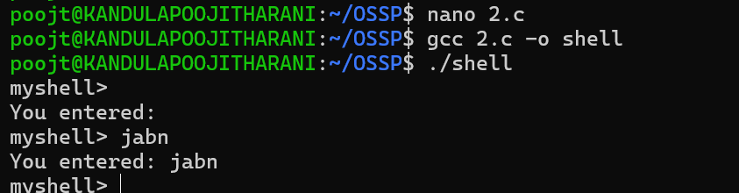

QUESTION 3
To Apply Escape Sequences, Store Command History, Navigate Previous Commands, Navigate Next Commands, Update Input Buffer, Test Recall Functionality.
#include <stdio.h>
#include <string.h>
#define MAX_HISTORY 5
int main() {
char history[MAX_HISTORY][100];
int count = 0;
char command[100];
printf("Enter commands (type history to display, exit to stop).\n");
while (1) {
printf("> ");
fgets(command, sizeof(command), stdin);
command[strcspn(command, "\n")] = '\0';
if (strcmp(command, "exit") == 0)
break;
if (strcmp(command, "history") == 0) {
for (int i = 0; i < count; i++)
printf("%d %s\n", i + 1, history[i]);
continue;
}
if (count < MAX_HISTORY)
strcpy(history[count++], command);
}
return 0;
}
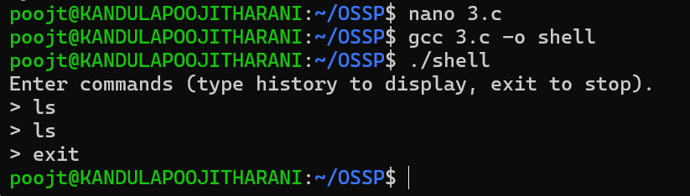

QUESTION 4
To Split Input into Tokens, Identify Delimiters, Handle Whitespace, Create Token Structures, Validate Token Streams, Debug Parsing Output.
#include <stdio.h>
#include <string.h>
int main() {
char input[200];
char *token;
printf("Enter command: ");
fgets(input, sizeof(input), stdin);
token = strtok(input, " \t\n");
while (token != NULL) {
printf("Token: %s\n", token);
token = strtok(NULL, " \t\n");
}
return 0;
}
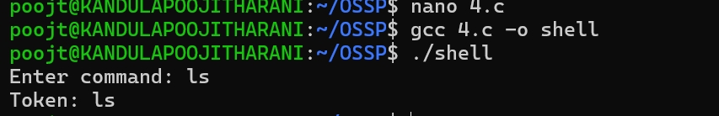

QUESTION 5
To Apply Single Quotes, Preserve Literal Content, Ignore Variable Expansion, Store Quoted Strings, Validate Parsing Results, Test Edge Cases.
#include <stdio.h>
int main() {
char input[] = "'hello $USER world'";
printf("Single quoted string: %s\n", input);
printf("Content inside single quotes is treated literally.\n");
return 0;
}
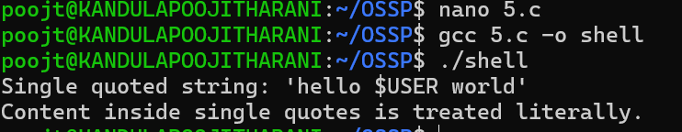

QUESTION 6
To Create Process Escape Sequences, Handle Escaped Spaces, Escape Special Symbols, Preserve Characters, Validate Parser Output, Test Complex Inputs.
#include <stdio.h>
#include <string.h>
int main() {
char input[] = "hello\\ world";
char output[100];
int j = 0;
for (int i = 0; input[i] != '\0'; i++) {
if (input[i] == '\\' && input[i + 1] != '\0')
i++;
output[j++] = input[i];
}
output[j] = '\0';
printf("Parsed: %s\n", output);
return 0;
}
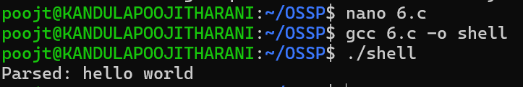

QUESTION 7
Process Synchronization and Child Process Monitoring Using waitpid().
#include <stdio.h>
#include <unistd.h>
#include <sys/wait.h>
int main() {
pid_t pid = fork();
if (pid == 0) {
sleep(2);
printf("Child finished.\n");
return 0;
}
printf("Parent waiting using waitpid()...\n");
waitpid(pid, NULL, 0);
printf("Child has terminated.\n");
return 0;
}
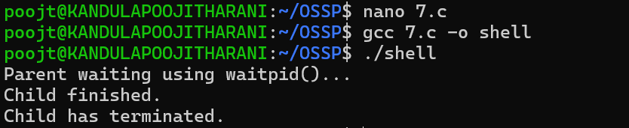

QUESTION 8
To Detect Variable References, Expand Values, Handle Undefined Variables, Update Tokens, Support Nested Variables, Test Expansion Logic.
#include <stdio.h>
#include <stdlib.h>
#include <string.h>
int main() {
char name[50];
char *value;
printf("Enter variable name: ");
scanf("%49s", name);
value = getenv(name);
if (value != NULL)
printf("%s=%s\n", name, value);
else
printf("Variable is undefined.\n");
return 0;
}
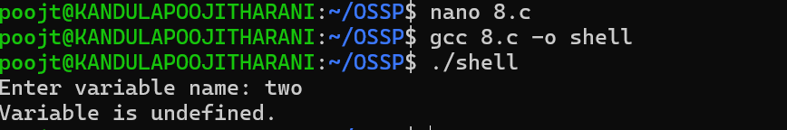

QUESTION 9
To Change Directories, Validate Paths, Update Working Directory, Handle Errors, Maintain Previous Directory, Test Navigation.
#include <stdio.h>
#include <unistd.h>
#include <limits.h>
int main() {
char path[PATH_MAX];
printf("Enter directory: ");
scanf("%s", path);
if (chdir(path) == -1) {
perror("chdir");
return 1;
}
if (getcwd(path, sizeof(path)) != NULL)
printf("Current directory: %s\n", path);
return 0;
}
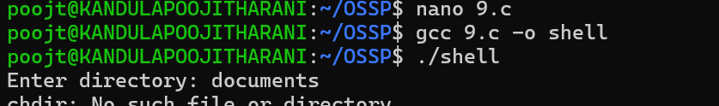

QUESTION 10
To Retrieve Current Directory, Display Path, Process Exit Requests, Cleanup Resources, Save State, Verify Correct Behavior.
#include <stdio.h>
#include <unistd.h>
#include <limits.h>
int main() {
char cwd[PATH_MAX];
if (getcwd(cwd, sizeof(cwd)) == NULL) {
perror("getcwd");
return 1;
}
printf("Current directory: %s\n", cwd);
printf("Type 'exit' in a shell to process an exit request.\n");
return 0;
}
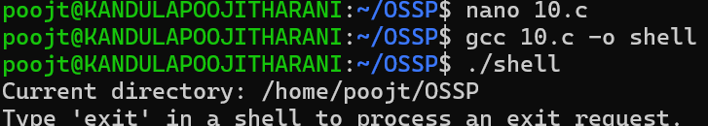

QUESTION 11
To Store Commands, Maintain History Buffer, Handle Capacity Limits, Retrieve Entries, Display History, Validate Consistency.
#include <stdio.h>
#include <string.h>
#define MAX 5
int main() {
char history[MAX][100];
int count = 0;
char cmd[100];
for (int i = 0; i < MAX; i++) {
printf("Command %d: ", i + 1);
fgets(cmd, sizeof(cmd), stdin);
cmd[strcspn(cmd, "\n")] = '\0';
strcpy(history[count++], cmd);
}
printf("\nHistory:\n");
for (int i = 0; i < count; i++)
printf("%d: %s\n", i + 1, history[i]);
return 0;
}
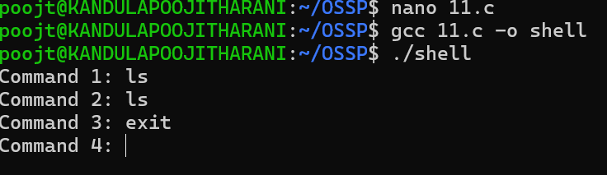

QUESTION 13
To Parse Input Redirection, Open Files, Redirect stdin, Handle Missing Files, Restore Streams, Test File Inputs.
#include <stdio.h>
#include <fcntl.h>
#include <unistd.h>
int main() {
int fd = open("input.txt", O_RDONLY);
if (fd < 0) {
perror("input.txt");
return 1;
}
dup2(fd, STDIN_FILENO);
close(fd);
char buffer[100];
if (fgets(buffer, sizeof(buffer), stdin))
printf("Read from redirected input: %s", buffer);
return 0;
}
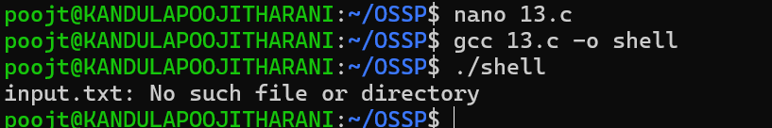
QUESTION 14
To Parse Append Operator, Open Files in Append Mode, Redirect Streams, Preserve Existing Data, Validate Appends, Test Scenarios.
#include <stdio.h>
#include <fcntl.h>
#include <unistd.h>
int main() {
int fd = open("output.txt", O_WRONLY | O_CREAT | O_APPEND, 0644);
if (fd < 0) {
perror("output.txt");
return 1;
}
dup2(fd, STDOUT_FILENO);
close(fd);
printf("This line is appended.\n");
return 0;
}
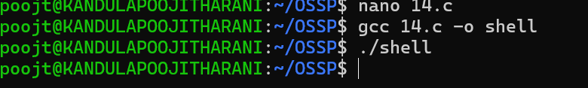
QUESTION 15
To Parse Combined Redirection, Duplicate File Descriptors, Merge Streams, Verify Ordering, Handle Edge Cases, Test Integrated Outputs.
#include <stdio.h>
#include <fcntl.h>
#include <unistd.h>
int main() {
int fd = open("combined.txt", O_WRONLY | O_CREAT | O_TRUNC, 0644);
if (fd < 0)
return 1;
dup2(fd, STDOUT_FILENO);
dup2(fd, STDERR_FILENO);
close(fd);
printf("Standard output message.\n");
fprintf(stderr, "Standard error message.\n");
return 0;
}
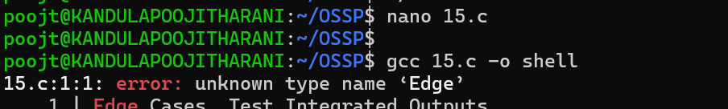
QUESTION 16
To Detect Background Jobs, Launch Non-Blocking Processes, Return Prompt Immediately, Store Job Information, Monitor Execution, Test Background Tasks.
#include <stdio.h>
#include <unistd.h>
#include <sys/wait.h>
int main() {
pid_t pid = fork();
if (pid == 0) {
sleep(5);
printf("Background job completed.\n");
return 0;
}
printf("Background job started. PID=%d\n", pid);
printf("Parent returns to prompt immediately.\n");
waitpid(pid, NULL, 0);
return 0;
}
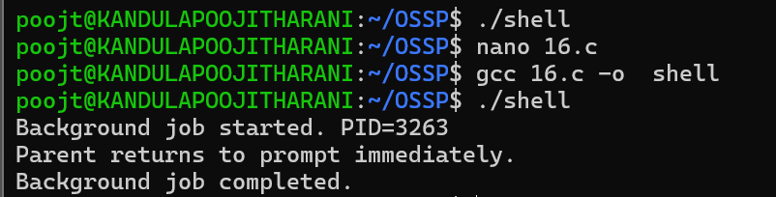

QUESTION 17
To Implement how to List Active Jobs, Display Status Information, Retrieve Job IDs, Format Output, Update State Information, Test Job Listings.
#include <stdio.h>
#include <unistd.h>
#include <sys/wait.h>
int main() {
pid_t pid = fork();
if (pid == 0) {
sleep(3);
return 0;
}
printf("[1] PID=%d Status=Running\n", pid);
waitpid(pid, NULL, 0);
printf("[1] PID=%d Status=Completed\n", pid);
return 0;
}
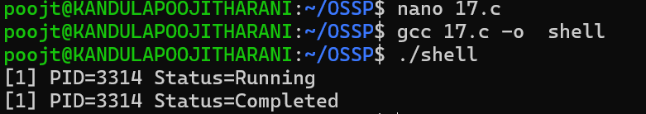

QUESTION 18
To Analyze Signal Delivery, Understand Signal Masks, Review Process Groups, Explore Terminal Signals, Test Signal Behavior.
#include <stdio.h>
#include <signal.h>
#include <unistd.h>
void handler(int sig) {
printf("Received signal: %d\n", sig);
}
int main() {
signal(SIGUSR1, handler);
printf("PID: %d\n", getpid());
printf("Send SIGUSR1 using: kill -USR1 PID\n");
while (1)
pause();
return 0;
}
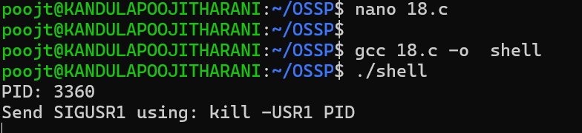

QUESTION 19
To Register Handlers, Configure Signal Actions, Handle Interrupts, Manage Signal Context, Verify Stability, Test Signal Events.
#include <stdio.h>
#include <signal.h>
#include <unistd.h>
void handler(int sig) {
printf("\nSignal %d received. Program is stable.\n", sig);
}
int main() {
struct sigaction sa;
sa.sa_handler = handler;
sigemptyset(&sa.sa_mask);
sa.sa_flags = 0;
sigaction(SIGINT, &sa, NULL);
sigaction(SIGTERM, &sa, NULL);
printf("PID: %d\n", getpid());
while (1)
pause();
return 0;
}
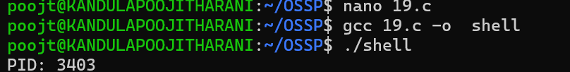
QUESTION 20
To Capture SIGTSTP, Suspend Processes, Update Job Table, Preserve State, Resume Later, Test Suspension Workflow.
#include <stdio.h>
#include <signal.h>
#include <unistd.h>
void handler(int sig) {
printf("\nSIGTSTP received. Process will stop.\n");
signal(SIGTSTP, SIG_DFL);
raise(SIGTSTP);
}
int main() {
signal(SIGTSTP, handler);
printf("PID: %d\n", getpid());
printf("Press Ctrl+Z to suspend.\n");
while (1) {
printf("Running...\n");
sleep(1);
}
return 0;
}
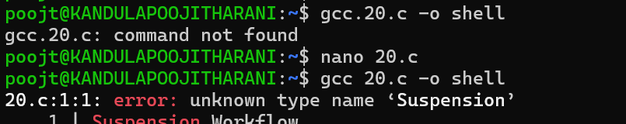

QUESTION 21
To Connect Modules, Validate Interfaces, Test End-to-End Execution, Handle Errors, Improve Reliability, Refactor Components.
#include <stdio.h>
int add(int a, int b) {
return a + b;
}
int main() {
int a = 10, b = 20;
printf("Module 1 result: %d\n", add(a, b));
printf("End-to-end module test completed.\n");
return 0;
}

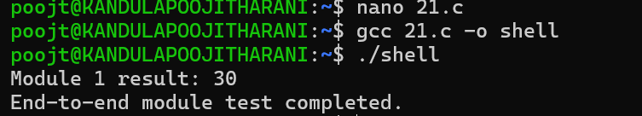
QUESTION 22
To Run Valgrind, Identify Leaks, Fix Memory Errors, Release Resources, Verify Cleanup, Document Findings.
#include <stdio.h>
#include <stdlib.h>
int main() {
int *ptr = malloc(10 * sizeof(int));
if (ptr == NULL)
return 1;
for (int i = 0; i < 10; i++)
ptr[i] = i;
printf("Memory allocated successfully.\n");
free(ptr);
printf("Memory released successfully.\n");
return 0;
}
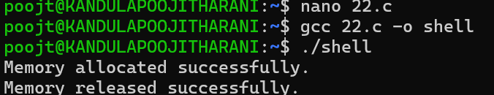
QUESTION 23
To Execute Large Pipelines, Launch Multiple Jobs, Measure Stability, Monitor Resources, Detect Failures, Analyze Performance.
#include <stdio.h>
#include <unistd.h>
#include <sys/wait.h>
#include <time.h>
int main() {
clock_t start = clock();
for (int i = 0; i < 3; i++) {
if (fork() == 0) {
printf("Pipeline job %d, PID=%d\n", i + 1, getpid());
sleep(1);
return 0;
}
}
for (int i = 0; i < 3; i++)
wait(NULL);
clock_t end = clock();
printf("All jobs completed.\n");
printf("CPU time: %.3f seconds\n",
(double)(end - start) / CLOCKS_PER_SEC);
return 0;
}
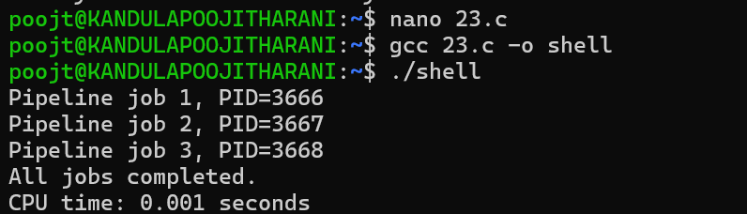

QUESTION 24
To Organize Source Code, Improve Build Scripts, Add README, Verify Repository Structure, Tag Releases, Validate Deliverables.
#include <stdio.h>
int main() {
printf("Project structure check\n");
printf("src/ - source files\n");
printf("include/ - header files\n");
printf("build/ - compiled files\n");
printf("README.md - project documentation\n");
printf("Makefile - build instructions\n");
return 0;
}
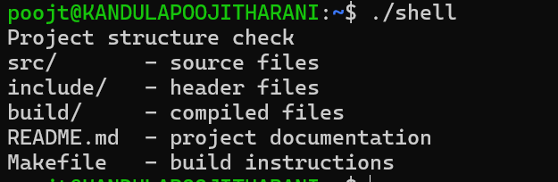
To Create Demo Scenarios, Validate Features, Rehearse Presentation, Demonstrate Pipelines, Demonstrate Signals, Final Project Review.
#include <stdio.h>
#include <signal.h>
#include <unistd.h>
void handler(int sig) {
printf("Demo signal received: %d\n", sig);
}
int main() {
signal(SIGUSR1, handler);
printf("OSSP Demo\n");
printf("PID: %d\n", getpid());
printf("Feature 1: Process execution\n");
printf("Feature 2: Pipelines\n");
printf("Feature 3: Signal handling\n");
printf("Sending demonstration signal...\n");
raise(SIGUSR1);
printf("Final project review completed.\n");
return 0;
}
